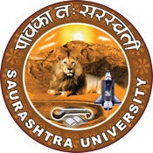

Institution’s Innovation Council
Saurashtra University

Visit to SNJ Labs Pvt. Ltd.

3rd August 2023

At

SNJ Labs Pvt. Ltd.
Nana Mava Road
Rajkot

Contents
Saurashtra University – IIC 2
Event Schedule 2
Event Registration Link 2
Brief about Event 3
Key Points 3
Outcome 3
Connect Us: 5

Saurashtra University – IIC
The university is dedicated to instruction, research, and extending knowledge to the public (public service). Ministry of Education (MoE), Govt. of India has established ‘MoE’s Innovation Cell (MIC)’ to systematically foster the culture of Innovation among all Higher Education Institutions (HEIs). The primary mandate of MIC is to encourage, inspire and nurture young students by supporting them to work with new ideas and transform them into prototypes while they are informative years. Saurashtra University is one the Organization that have constituted the IIC to foster the vision of MoE and be a part for the promotion and development of innovation ecosystem.

Event Schedule

Event Registration Link

bit.ly/SUSEC-SNJ

Brief about Event

SU Start-up and Entrepreneurship Council and IIC Saurashtra University was in collaboration with Department of Pharmacy organized visit at "SNJ Labs Pvt. Ltd." on 3rd August, 2023. 64 students including staff members for visit. Department of Pharmaceutical Sciences, Rajkot had arranged an industrial visit for B. Pharm 3rd year & M. Pharm 2nd year students on 03rd August, 2023 at SNJ Labs Pvt. Ltd.

Then one representative of company gave presentation to get basic idea about industry. After that we took lunch arranged by SNJ Labs Pvt. Ltd. Afterwards the students were divided into different groups and visited different plant. Then visited APIS and powder preparations plant for iron sucrose powder, iron sucrose, iron sorbitol, ca – salt of alpha – keto leucine, ca – salt of alpha – keto isoleucine etc. Next, we visited to powder processing area, manufacturing area. Also, student visit at pilot scale plant, utility service area where we were given Information about utility area. Then visited Research & Development Department and QC and QA department.

The visit to SNJ Labs Pvt. Ltd. was really helpful for students in their career enhancement. Finally, we reached college campus Rajkot at 04:00 pm.

Key Points

During the session, below mentioned points were discussed:

- Presentation by company representative
- Group plant tours
- APIS and powder preparations plant visit
- Visit of powder processing area and manufacturing area
- Visit at pilot scale plant visit and utility service area information
- FAQs related to SNJ Labs Pvt. Ltd.

Outcome

According to the visit the student learned about how pharmaceutical companies worked. First company representative introduced students to the industry through a presentation. students were split into groups to explore different sections of the plant. They toured plants for products like iron sucrose, iron sorbitol, and more, as well as areas like powder processing, manufacturing, and a pilot scale plant. The visit included utility services, R&D, QC, and QA departments. This exposure greatly benefited students' career development.

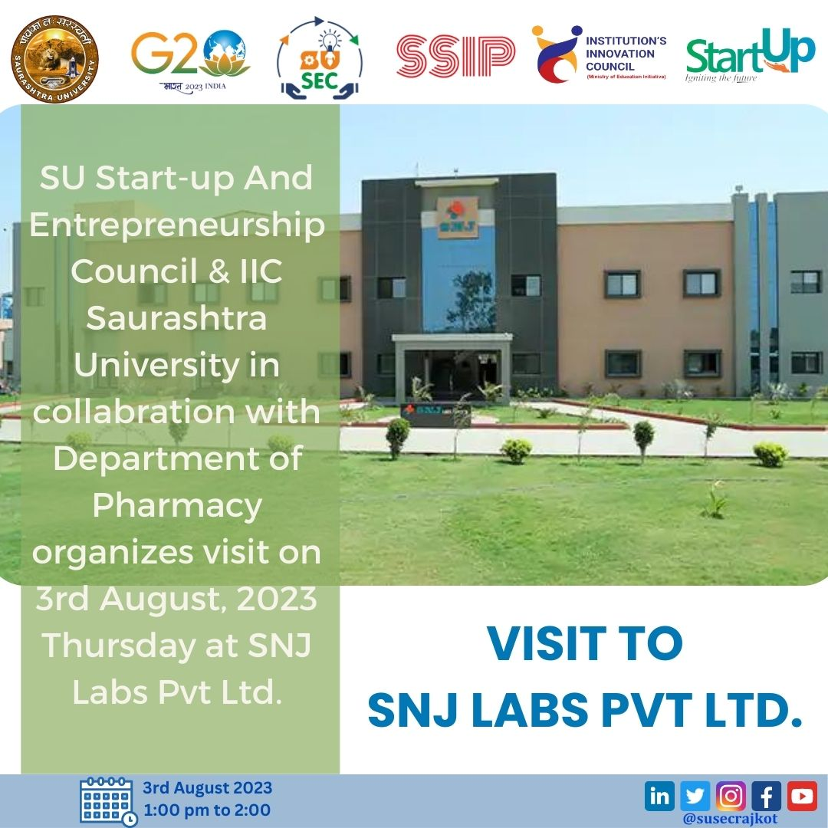

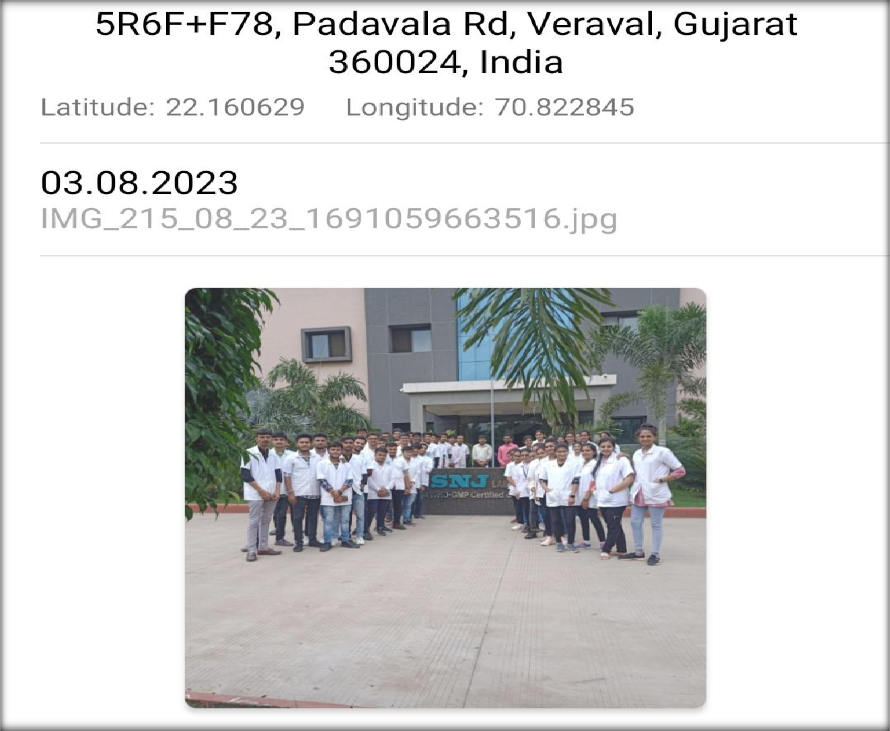

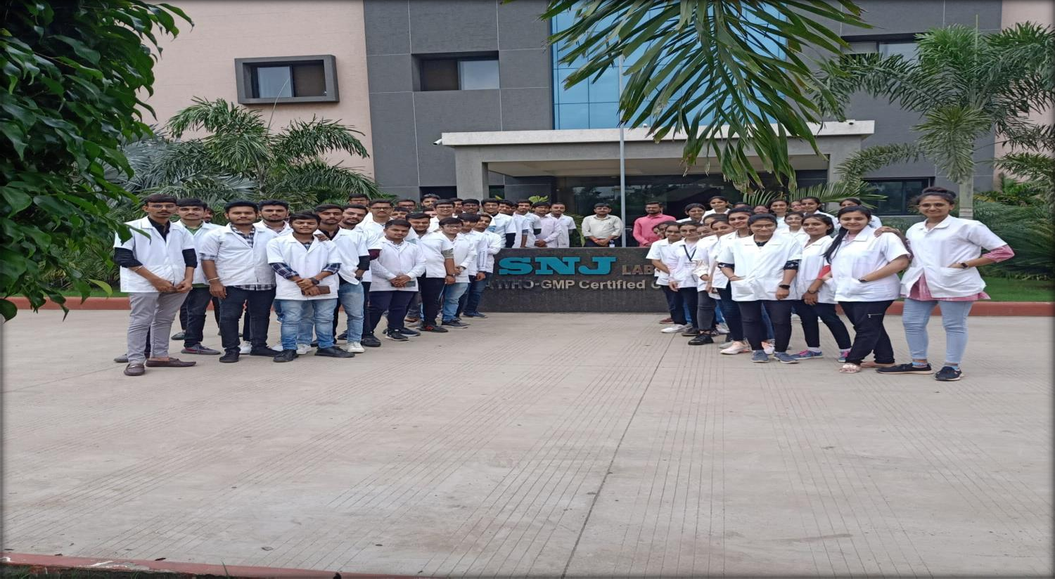

Connect Us:

https://www.linkedin.com/company/susec iic@sauuni.ac.in
https://www.facebook.com/iicsauuni https://bit.ly/SUSECLocation
https://www.instagram.com/susecrajkot https://bit.ly/SUSEC-youtube

